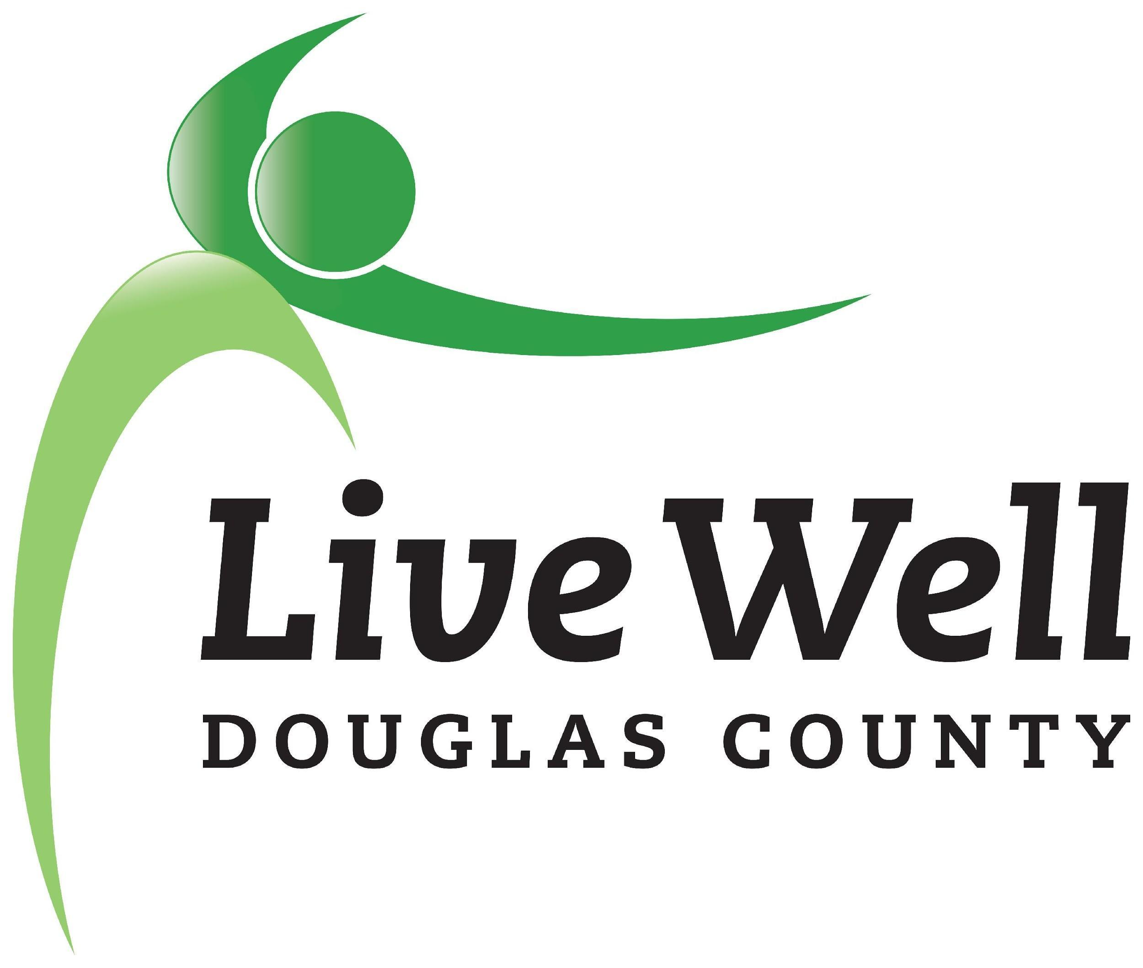
LiveWell Executive Team
Meeting Agenda

January 19, 2021, 9:00-10:00am
Online via Zoom

Item | Notes | Action step
Introductions | Welcome Valorie!
Review of agenda | Additions?
Sexual Violence Prevention MOU Update | - Update on MOU, agreement will be fulfilled  - Meeting with Gabby to plan out work and responsibilities  - Discussion of future agreement, funding
BCBS Pathways Grant Update | - Update on Packages  - Update on new long-term (5-10 year) goals section of grant  - Incorporate CHP goals  - Evaluation discussion  - BCBS receptive to survey burnout concerns  - Decide to choose focus groups 1-3, with supplemental interviews  - Potential to apply for KHF Impact Grant for Double Up Food Bucks  - Marlin has submitted a request for emergency Community Development Block Grant dollars to “triple up” instead of “double up”  - Measurements - review by Exec Committee, relevant Work Groups  - Christina brought up use of Tobacco-related community check box indicators | Valorie will share 2018 HER and most-up-to-date CHP  Marty will send around measurements, Exec members will review  Christina will lead followup on measurement technology (community check box indicators, etc)
Reminder: leadership transition in 6 months
 | - City of Lawrence hiring community coordinators re: Climate Change plan

Attendance: Marlin Bates, Valorie Carson, Chris Tilden, Marty Scott, Christina Holt, Beth Llewellyn, Joey Hentzler

